**AWS CLOUDWATCH SERVICE**

🡪open cloudwatch

🡪see all the metrics for tracking the usage

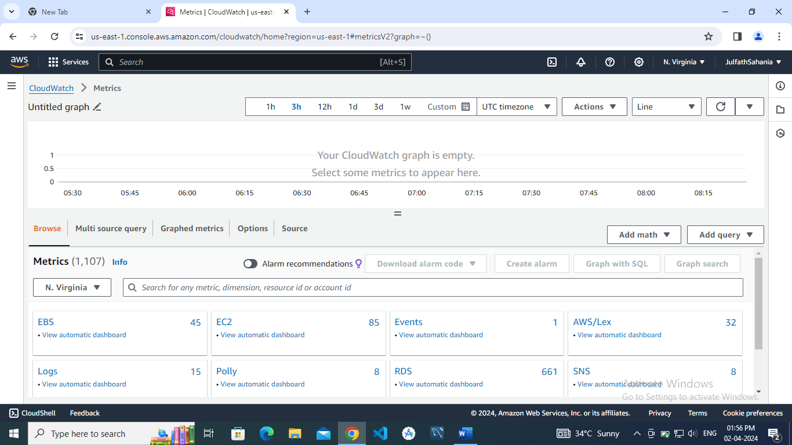

🡪open events to create a rule

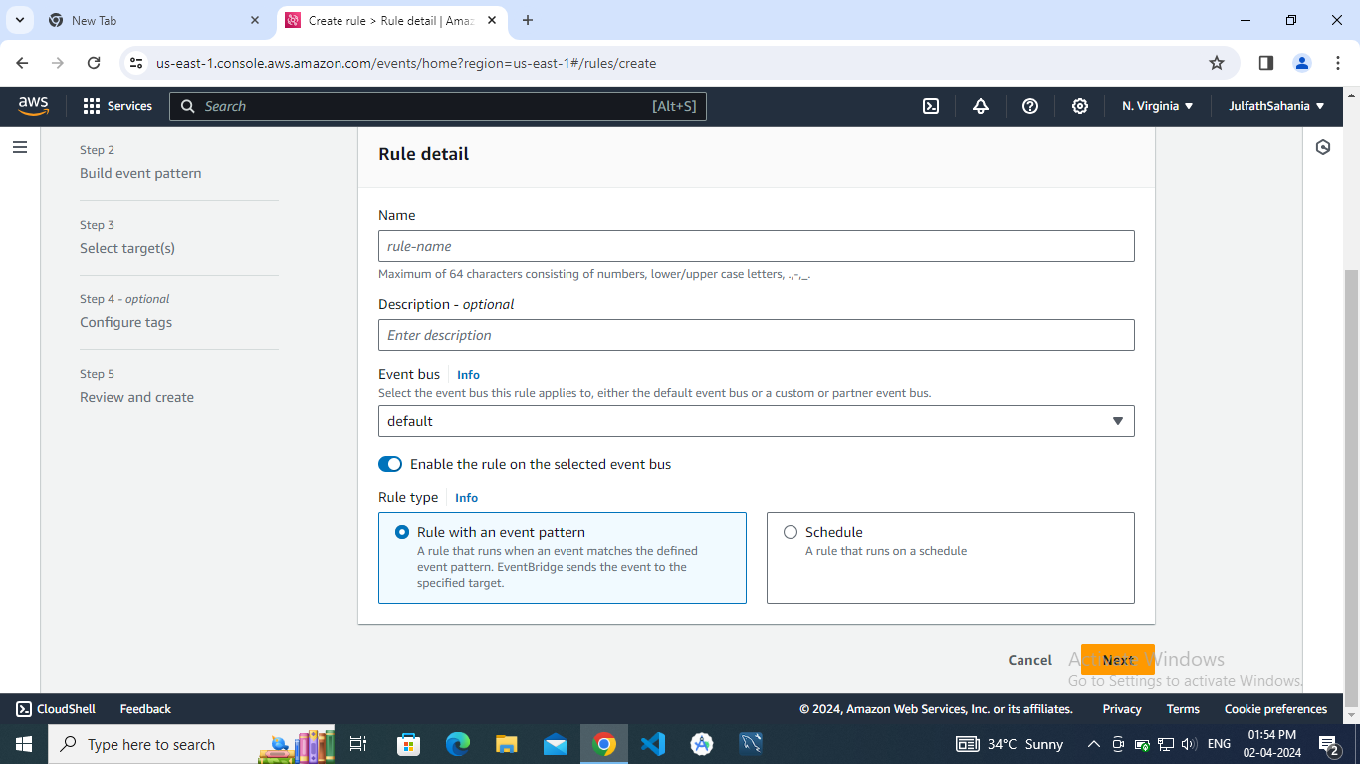

🡪see log groups

